**Learning Outcomes**

* Add,Edit,Delete and View to-do items for individual users

Create a new layout **ToDo.axml**

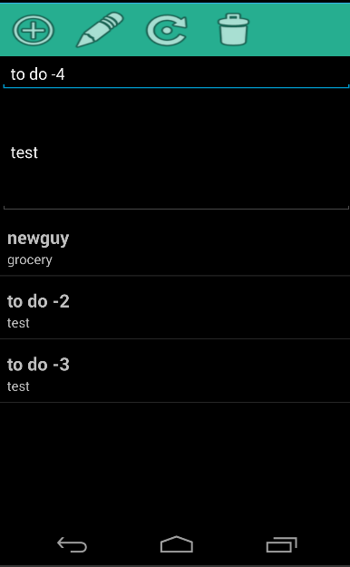

**ToDo.axml**

**ToDoActivity.cs**

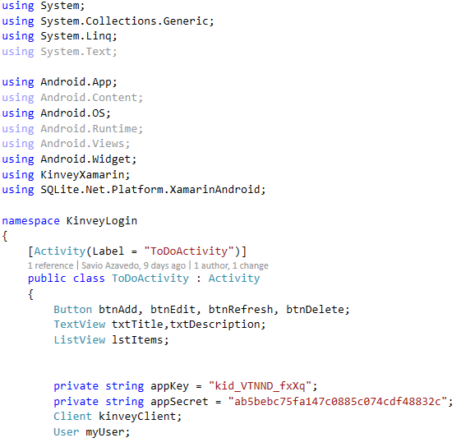

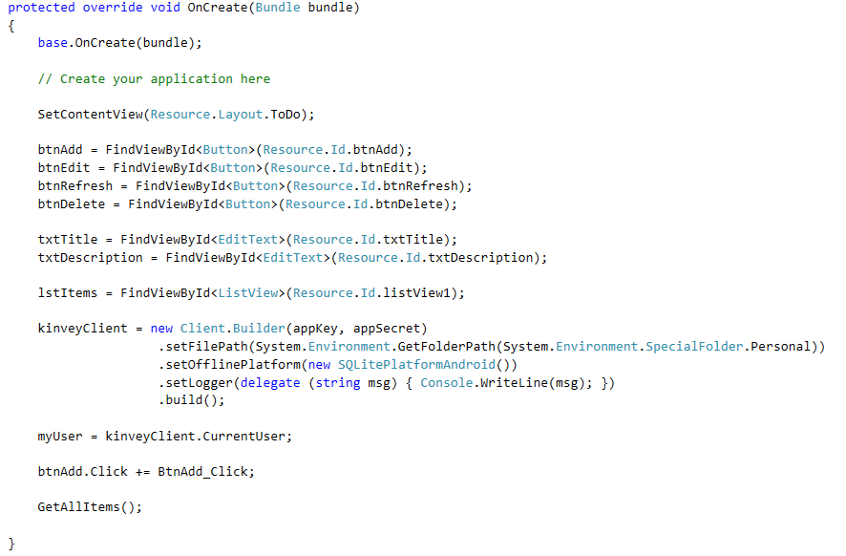

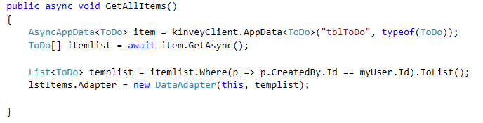

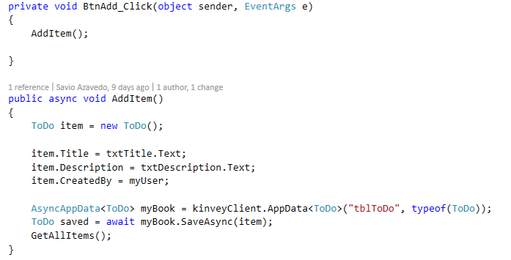

**Exercise**

**Complete the following functions**

